**Topological sort**

Given a Directed Acyclic Graph with V vertices and E edges, Find any Topological Sorting of that Graph.

**Example 1:**

**Input:**

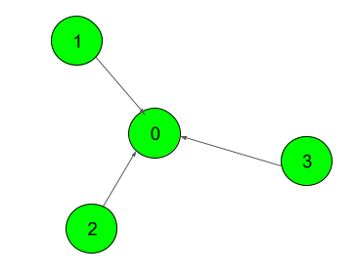

**Output:**

1

**Explanation**:

The output 1 denotes that the order is

valid. So, if you have, implemented

your function correctly, then output

would be 1 for all test cases.

One possible Topological order for the

graph is 3, 2, 1, 0.

**Example 2:**

**Input:**

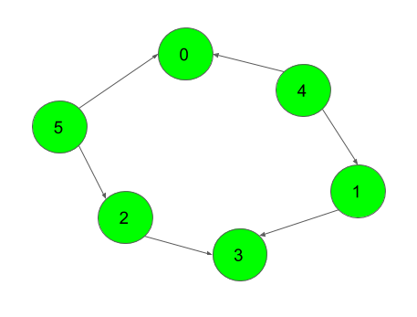

**Output:**

1

**Your Task:**  
You don't need to read input or print anything. Your task is to complete the function **topoSort()**  which takes the integer V denoting the number of vertices and adjacency list as input parameters and returns an array consisting of a the vertices in Topological order. As there are multiple Topological orders possible, you may return any of them.

**Expected Time Complexity:** O(V + E).  
**Expected Auxiliary Space:** O(V).

**Constraints:**  
2 ≤ V ≤ 104  
1 ≤ E ≤ (N*(N-1))/2